HAFIZ MOHSIN RAZA

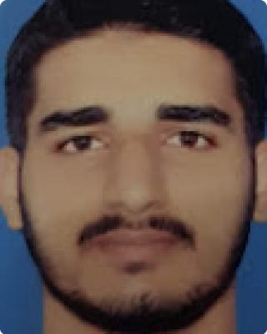

|  |  |  |  |
| --- | --- | --- | --- |
| E-mail : | hafizmmohsinraza@gmailcom | Phone : | 03374677342 |
| Address: | HOUSE# 455 P Block sabzazar Lahore | |  |

Work experience



Online Quran Teacher ,Freelancer,Fiver,Guru 2016 — Present

Data Entry

Qualifications



BSc Computer Science From University of Engineering and Technology ,Lahore

Education



|  |  |
| --- | --- |
| Fsc Pre-Engineering | 2017 — 2019 |
| Bise Lahore |  |
| Matric | 2016 — 2017 |
| Bise Lahore |  |

Hifz-ul-Quran

Dare Arqam 2012­­­­­­-2014

Interests



Arabic,Programming ,Cricket ,Graphic Designing ,

References



References available upon request.

HAFIZ MOHSIN RAZA 1